Multiple Choice Questions

1) If a peptide was composed entirely of α-helical structure and found to contain an integer number of complete turns, which of the following would be a possible number of amino acid residues in the peptide?

A) 12
B) 20
C) 32
D) 36
E) 60

Answer: D

Difficulty: 2 Topic: Secondary Structure

2) In an α-helix, a hydrogen bond is formed between the carbonyl oxygen of the i^{th} residue and the amide hydrogen _____ residues away

A) i + 1
B) i + 2
C) i + 3
D) i + 4
E) i + 5

Answer: D

Difficulty: 1 Topic: Secondary Structure

3) Which of the following is true regarding β-sheet structures?

A) hydrogen bonds in an parallel sheet are non-linear
B) hydrogen bonds in an antiparallel sheet are non-linear
C) the rise per residue is greater for a parallel sheet than for an antiparallel sheet
D) β-sheets are an n=3 helix with each residue rotated 120° with respect to its neighbors
E) none of the above

Answer: A

Difficulty: 2 Topic: Secondary Structure

4) Which of the following types of secondary structure has a non-integer value of residues per turn?

A) antiparallel β-sheet
B) parallel β-sheet
C) α-helix
D) 3₁₀ helix
E) polyproline II helix

Answer: C

Difficulty: 1 Topic: Secondary Structure

5) The two amino acids most often found in a polyproline II helix are proline and _______.

A) alanine
B) glycine
C) serine
D) lysine
E) histidine

Answer: B

Difficulty: 1 Topic: Secondary Structure

6) Which of the following correctly defines the angles φ and ψ?

A) φ: N-C_{α}; ψ: C_{α}-C_{β}
B) φ: N-C_{α}; ψ: C_{α}-C_{carbonyl}
C) φ: C_{carbonyl}-N_{(i + 1)}; ψ: N-C_{α}
D) φ: C_{carbonyl}-N_{(i + 1)}; ψ: C_{α}-C_{carbonyl}
E) φ: C_{α}-C_{β}; ψ: N-C_{α}

Answer: B

Difficulty: 2 Topic: Secondary Structure

7) In a typical Ramachandran plot, _____ is plotted vs _____ to illustrate _______.

A) φ; ψ; dependence of ψ upon φ
B) ψ; φ; dependence of φ upon ψ
C) φ; ψ; allowable combinations of ψ and φ
D) ψ; φ; allowable combinations of ψ and φ
E) none of the above

Answer: D

Difficulty: 1 Topic: Secondary Structure

8) Which of the following statements regarding structural proteins is true?

A) silk fibroin is made from a repeat of three amino acids where each third amino acid is Gly
B) α-keratin is composed of peptides that contain mostly α–helical structure with the exception of short sequences where the peptide folds back on itself
C) collagen has its own helical structure where three individual peptides are wound around each other in a left-handed helix
D) generally speaking, structural proteins are soluble in water
E) none of the above

Answer: C

Difficulty: 2 Topic: Fibrous Proteins

9) The presence of a hydrophobic amino acid at every third or fourth residue in α-keratin results in which of the following?

A) a random placement of hydrophobic amino acids within the helix
B) a strip of hydrophobic surface area that, when combined with another monomer, results in the formation of a dimer through hydrophobic interactions
C) a strip of hydrophobic surface area that causes individual α-keratin molecules to fold back on themselves through hydrophobic interactions
D) represents a deleterious mutation that causes the α-keratin molecules to aggregate and form plaques
E) none of the above

Answer: B

Difficulty: 2 Topic: Fibrous Proteins

10) What type of interaction occurs between the β-sheets of fibroin?

A) charge-dipole interaction
B) dipole-dipole interaction
C) dipole-induced dipole interaction
D) van der Waals interaction
E) hydrogen bonding

Answer: D

Difficulty: 2 Topic: Fibrous Proteins

11) Which of the following structural proteins is correctly paired with the modified amino acid or cross-link that is an integral part of that protein?

A) collagen: 5-hydroxylysine
B) elastin: hydroxyproline
C) α-keratin: cross link formed by oxidation of lysine, then aldol condensation
D) collagen: desmosine
E) fibroin: cross-link formed by dehydration of serine residues

Answer: A

Difficulty: 2 Topic: Fibrous Proteins

12) Which of the following would contribute to tertiary structure?

A) charge-charge interaction between lysine and aspartic acid
B) disulfide bond
C) hydrogen bond between serine hydroxyl group and amide of glutamine
D) hydrophobic interaction between leucine and valine
E) all of the above

Answer: E

Difficulty: 2 Topic: Globular Proteins

13) Which of the following elements of secondary structure are observed in the following protein?
A) antiparallel β-sheet
B) parallel β-sheet
C) an α-helix of at least 20 amino acid residues
D) 3₁₀ helix
E) none of the above

Answer: A

Difficulty: 2 Topic: Globular Proteins

14) To which domain class would the following protein belong?
A) mainly α
B) mainly β
C) α + β
D) few 2° structures
E) α/β barrel

Answer: A

Difficulty: 2 Topic: Globular Proteins

15) Which of the following is a highly compact structure that is very commonly used to transition from one region of secondary structure to another in a globular protein?

A) α bend
B) β turn
C) α/β hairpin
D) high-glycine loop
E) none of the above

Answer: B

Difficulty: 1 Topic: Globular Proteins

16) Which of the following causes denaturation of a protein when disulfide bonds are present?

A) heat
B) pH changes
C) reducing agent
D) detergent
E) all of the above

Answer: C

Difficulty: 1 Topic: Factors Determining Secondary and Tertiary Structure

17) Which of the following contributes to a positive ΔG for protein folding?

A) conformational entropy
B) hydrophobic effect
C) charge-charge interactions
D) internal hydrogen bonds
E) van der Waals interactions

Answer: A

Difficulty: 1 Topic: Factors Determining Secondary and Tertiary Structure

18) A protein with five disulfide bonds was treated with β-mercaptoethanol and urea. Once the protein was denatured, the β-mercaptoethanol and urea were removed by dialysis. What is the likelihood that all five disulfide bonds will reform correctly?

A) 1/5 or 20%
B) 1/10 or 10%
C) 1/10² or 4%
D) 1/5! = 1/120 or 0.83%
E) 1/945 or 0.11%

Answer: E

Difficulty: 3 Topic: Factors Determining Secondary and Tertiary Structure

19) Of the following proteins that aid in the folding process, which is exclusively involved in the interconversion of cis and trans bonds?

A) prolyl isomerase
B) protein disulfide isomerase
C) Hsp60
D) Hsp70
E) GroEl-ES complex

Answer: A

Difficulty: 1 Topic: Dynamics of Globular Protein Structure

20) Which of the following is considered a dead-end complex (and therefore dangerous due to its resistance to proteolytic cleavage) in the protein-folding pathway?

A) disordered aggregate
B) molten globule state
C) prefibrillar species
D) amyloid fibril
E) unfolded protein

Answer: D

Difficulty: 1 Topic: Dynamics of Globular Protein Structure

21) Which amino acid is often referred to as a “helix-breaker” due to its absence from α-helices but is often found in structures such as β-turns?

A) Val
B) Met
C) Pro
D) Phe
E) Leu

Answer: C

Difficulty: 2 Topic: Prediction of Secondary and Tertiary Protein Structure

22) Which of the following could contribute to quaternary structure?

A) charge-charge interaction between arginine and glutamic acid
B) disulfide bond
C) hydrogen bond between threonine hydroxyl group and imidazole ring of histidine
D) hydrophobic interaction between phenylalanine and tryptophan
E) all of the above

Answer: E

Difficulty: 2 Topic: Quaternary Structure of Proteins

23) If two protein subunits produced the following structure, what term would be used to describe the interactions that hold the two peptides together?
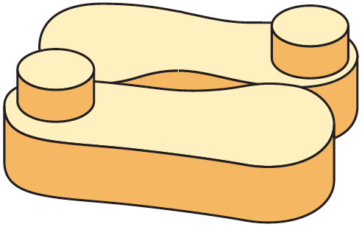
A) point-group symmetry interactions
B) dyad axis symmetry interactions
C) isologous interactions
D) dihedral symmetry interactions
E) none of the above

Answer: C

Difficulty: 2 Topic: Quaternary Structure of Proteins

Short Answer Questions

1) Draw a section of antiparallel β-sheet showing two sheets with three residues in each sheet. Clearly show the hydrogen bond pattern between the two sheets.

Answer:
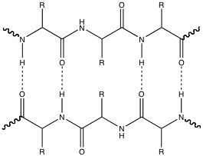

Difficulty: 2 Topic: Secondary Structure

2) Show the most likely interaction that would occur between a serine residue and a glutamine residue.

Answer: the structure below shows both amino acids acting as a donor and acceptor

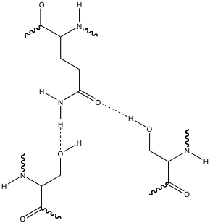

Difficulty: 2 Topic: Factors Determining Secondary and Tertiary Structure

3) Show the reaction catalyzed by prolyl isomerase. Indicate the configuration of both substrate and product.

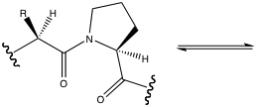

Answer:
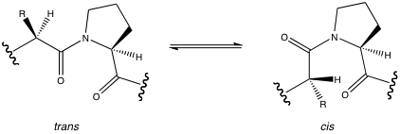

Difficulty: 2 Topic: Dynamics of Globular Protein Structure

